[**Faster Fog**](https://blog.mmacklin.com/2010/06/10/faster-fog/)

June 11, 2010

[Cedrick](http://ccollomb.free.fr/blog/) at Lucas suggested some nice optimisations for the in-scattering equation I posted [last time](http://mmack.wordpress.com/2010/05/29/in-scattering-demo/).

I had left off at:

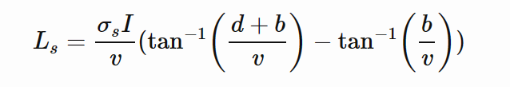

But we can remove one of the two inverse trigonometric functions by using the following identity:

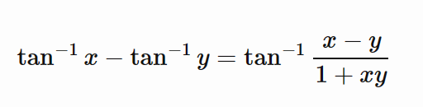

Which simplifies the expression for Ls to:

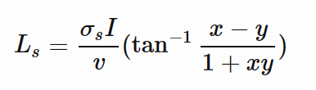

With x and y being replaced by:

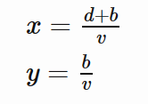

So the updated GLSL snippet looks like:

float InScatter(vec3 start, vec3 dir, vec3 lightPos, float d)

{

vec3 q = start - lightPos;

// calculate coefficients

 float b = dot(dir, q);

 float c = dot(q, q);

 float s = 1.0f / sqrt(c - b*b);

 // after a little algebraic re-arrangement

  float x = d*s;

  float y = b*s;

  float l = s * atan( (x) / (1.0+(x+y)*y));

  return l;

}

Of course it's always good to verify your 'optimisations', ideally I would take GPU timings but next best is to run it through NVShaderPerf and check the cycle counts:

Original (2x atan()):

Fragment Performance Setup: Driver 174.74, GPU G80, Flags 0x1000

Results 76 cycles, 10 r regs, 2,488,320,064 pixels/s

Updated (1x atan())

Fragment Performance Setup: Driver 174.74, GPU G80, Flags 0x1000

Results 55 cycles, 8 r regs, 3,251,200,103 pixels/s

A tasty 25% reduction in cycle count!

Another idea is to use an approximation of atan(), Robin Green has some great articles about [faster math functions](http://www.research.scea.com/gdc2003/fast-math-functions.html) where he discusses how you can range reduce to 0-1 and approximate using [minimax polynomials](http://mathworld.wolfram.com/MinimaxPolynomial.html).

My first attempt was much simpler, looking at it's graph we can see that atan() is almost linear near 0 and asymptotically approaches pi/2.

[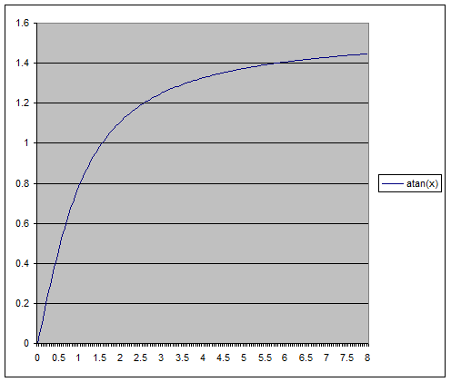](https://blog.mmacklin.com/wp-content/uploads/2010/06/atan.png)

Perhaps the simplest approximation we could try would be something like:

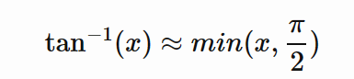

Which looks like:

[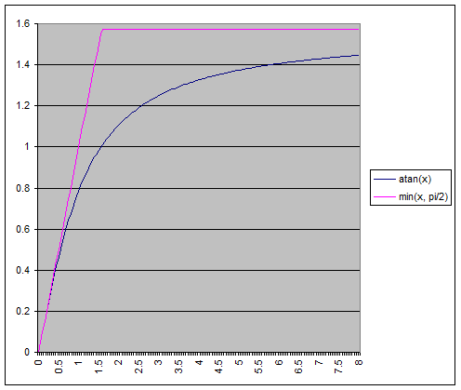](https://blog.mmacklin.com/wp-content/uploads/2010/06/atan_approx.png)

float atanLinear(float x)

{

return clamp(x, -0.5*kPi, 0.5*kPi);

}

// Fragment Performance Setup: Driver 174.74, GPU G80, Flags 0x1000

// Results 34 cycles, 8 r regs, 4,991,999,816 pixels/s

Pretty ugly, but even though the maximum error here is huge (~0.43 relative), visually the difference is [surprisingly small](https://blog.mmacklin.com/wp-content/uploads/2010/06/linear.png).

Still I thought I'd try for something more accurate, I used a 3rd degree minimax polynomial to approximate the range 0-1 which gave something practically identical to atan() for my purposes (~0.0052 max relative error):

[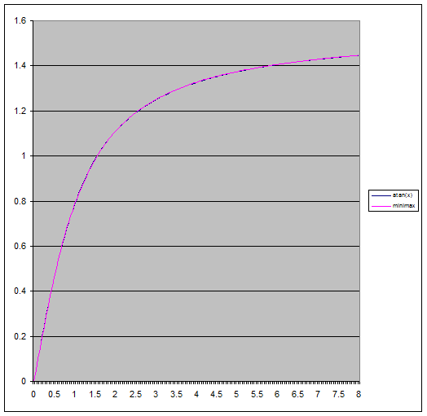](https://blog.mmacklin.com/wp-content/uploads/2010/06/atan_minimax.png)

float MiniMax3(float x)

{

return ((-0.130234*x - 0.0954105)*x + 1.00712)*x - 0.00001203333;

}

float atanMiniMax3(float x)

{

// range reduction

if (x < 1)

return MiniMax3(x);

else

 return kPi*0.5 - MiniMax3(1.0/x);

}

// Fragment Performance Setup: Driver 174.74, GPU G80, Flags 0x1000

// Results 40 cycles, 8 r regs, 4,239,359,951 pixels/s

*Disclaimer: This isn't designed as a general replacement for atan(), for a start it doesn't handle values of x < 0 and it hasn't had anywhere near the love put into other approximations you can find online (optimising for floating point representations for example).*

As a bonus I found that putting the polynomial evaluation into [Horner form](http://en.wikipedia.org/wiki/Horner_scheme) shaved 4 cycles from the shader.

Cedrick also had an idea to use something a little different:

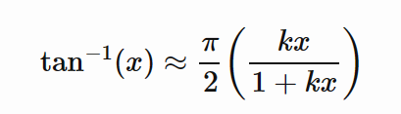

This might look familiar to some as the basic Reinhard [tone mapping](http://filmicgames.com/archives/category/tonemapping) curve!  We eyeballed values for k until we had one that looked close (you can tell I'm being very rigorous here), in the end k=1 was close enough and is one cycle faster :)

[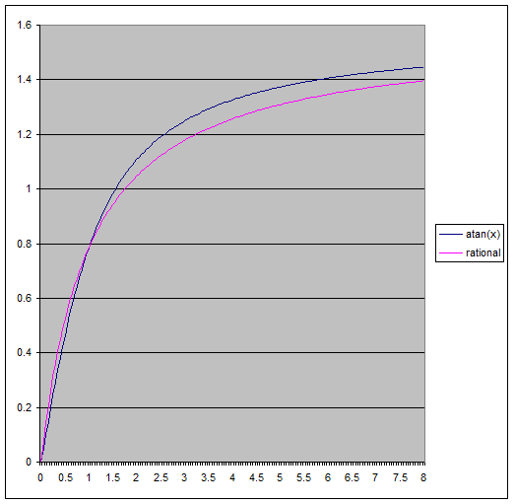](https://blog.mmacklin.com/wp-content/uploads/2010/06/atan_rational1.png)

float atanRational(float x)

{

return kPi*0.5*x / (1.0+x);

}

// Fragment Performance Setup: Driver 174.74, GPU G80, Flags 0x1000

// Results 34 cycles, 8 r regs, 4,869,120,025 pixels/s

To get it down to 34 cycles we had to expand out the expression for x and perform some more grouping of terms which shaved another cycle and a register off it.  I was surprised to see the rational approximation be so close in terms of performance to the linear one, I guess the scheduler is doing a good job at hiding some work there.

In the end all three approximations gave pretty good visual results:

Original (cycle count 76):

[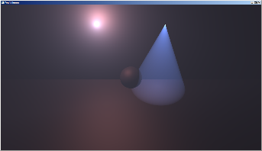](https://blog.mmacklin.com/wp-content/uploads/2010/06/original.png)

MiniMax3, Error 8x (cycle count 40):

[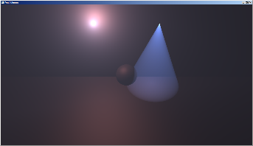](https://blog.mmacklin.com/wp-content/uploads/2010/06/minimax3.png)[](https://blog.mmacklin.com/wp-content/uploads/2010/06/minimax3_diff.png)

Rational, Error 8x (cycle count 34):

[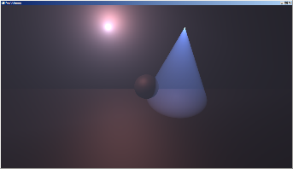](https://blog.mmacklin.com/wp-content/uploads/2010/06/rational.png)[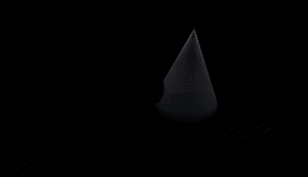](https://blog.mmacklin.com/wp-content/uploads/2010/06/rational_diff2.png)

Linear, Error 8x (cycle count 34):

[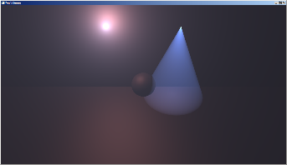](https://blog.mmacklin.com/wp-content/uploads/2010/06/linear.png)[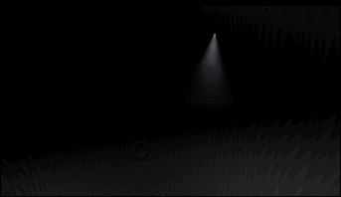](https://blog.mmacklin.com/wp-content/uploads/2010/06/linear_diff.png)

Links:

<http://realtimecollisiondetection.net/blog/?p=9>

<http://www.research.scea.com/gdc2003/fast-math-functions.html>